HS Civil Rights Template for Lesson 1: When and how to report when your rights have been violated

Objectives  Students will be able to...  - Use communication and social skills to positively interact with others by referring to shared working agreements.  - Demonstrate awareness of key vocabulary terms.  - Understand how to get help and support. | Materials Needed  - Internet for YouTube video  - Handout: Key vocabulary terms  - Teacher edition of handout: Key vocab terms and definitions  - Post-it notes-one for each student.  - Poster paper on the wall or board available for display of post-it notes.

Time | Description and Talking Points | PPT Slides
1-3  Minutes | Warm-up: Introduce “Civil Rights and Me” presentation and go over objectives and WCSD Policy (Slides 2 & 3) | 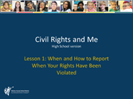
1-5 minutes | Discussion: Go over with the class the working agreements. Facilitate class discussion about them—"what do they mean to you?” | 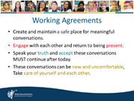
1-3 minutes | Key Vocabulary (HANDOUT):  Handout list of terms and mixed definition. Read each vocabulary word to the class and ask them to match the term with the definition. | 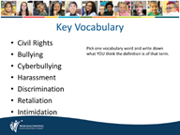
1-2 minutes | Lecture: Read the slides and the information to the class.  Before revealing the answers to the key vocabulary, please read the next two slides to the class. This is information for students to know about what a safe and respectful learning environment involves. | 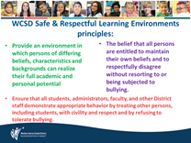
5-15 minutes | Compare student answers with formal definition slides  Discussion:  Any surprises? Agree with the definitions? Any comments to add? | 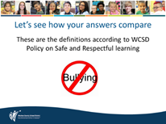
1-3  minutes | How to report  Talk about the many ways students can report when their rights, or the rights of others, have been violated | 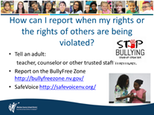
3:40  Minute video | Video: Telling an adult  https://youtu.be/l3oMe-32P80 | 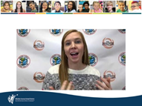
1-5 minutes | Telling vs Snitching  Go over the slide and discuss the differences between the two. Ask for examples if anyone has any to offer. | 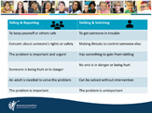
3-5 minutes | SafeVoice power point | 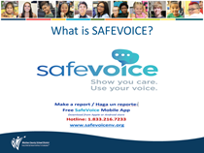
5-10  minutes | Wrap-Up: Positive Post-its  Students write down 3 positive outcomes related to reporting – put up on a poster around the room.  Small group/1-2 student gallery walk when done | 